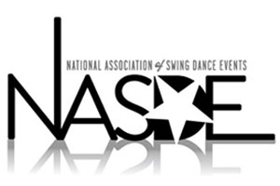

NASDE Application for Membership

Application date: ___________

Event name: ______________________________

Event website: _____________________________

Location: City: ____________________ State: ________

Event dates: Current year: ________ Next year: ________

How many years has the Event been operating? _______

Has ownership of the Event been the same for the past two years? ____ yes ____ no

If no, who was previous owner? ____________________________

Couple routine competitions currently offered at your Event (check all that apply):

____ Classic _____ Showcase

Event Ownership/Director Info:

Contact name(s): __________________

Contact phone number: ______________

Contact email: ____________________

Email application to: info@nasde.net

